Sarah Legg
Plnt 4790
Dr. Wilson
01 March 2010
Karibu Kenya
When I signed up for the plant 4790 class to Kenya, I knew that I would learn a lot on the trip, but I had no idea as to the extent and depth of the knowledge that I would acquire. I expected to learn about sustainable agriculture practices and Kenyan culture, but I wasn’t aware that the knowledge I would gain would extend into my everyday life. I went to Africa with an open mind, not knowing what to expect, and certainly not knowing that this trip would change my life.
Upon arrival in Nairobi, the first agricultural institute that we saw was the greenhouse and garden of Ibrahim and Diane Omondi. The garden was home to a variety of vegetables, and the greenhouse contained row after row of bell peppers. Upon entering, we were instructed to step into a plastic red tub containing a dark brown spongy substance that disinfected our shoes and therefore prevent diseases from entering the greenhouse. After touring the greenhouse, we spent the rest of the day recovering from jet lag and visiting several places in Nairobi, including an animal orphanage and the infamous Masai market.
The next day, we toured three non-governmental organizations (NGOs), all of which focused on sustainable agriculture. The first was a boys’ prison that was under the operation of RODI, the Resource Oriented Development Initiative. The prison housed boys between the ages of 16 and 22 that had committed minor offences. The compound itself was home to a rather large garden as well as a composting operation and generously-sized rabbit and goat houses. The director and his son explained to us that the goal of the prison was not to simply punish the prisoners, but rather to teach them life skills, such as soap-making, sustainable farming, composting, yogurt-making, seed collecting, and bleach-making. This way, upon their release from the prison, the boys would have a way to make a living, as well as a life skill that would render them a well respected member of society instead of a criminal. Three of the prisoners gave us a composting tutorial and showed us how they used worms, as well as liquid manure to break down organic material and convert it into rich, fertile soil. We also were shown the garden and the animal houses. Eventually, we were lead into a building with one large room. There, we were introduced to the prisoners and they shared with us their knowledge of yogurt making, soap making, bleach making or whatever other skill they had learned.
Before we left, we all gathered in the center of the room and sang all three verses of Silent Night together. Not five minutes previously, one of the boys had come over to me and, grabbing my arm, had asked me to come and sing with him. Standing next to him then, his arms proudly outstretched, he held a spiral notebook with the lyrics to all three verses hand-written on the page. As the versus played by, I noticed that most of the words on the page weren’t really words, but rather just letters put together in a phonetic way so that when spoken, they made the same sounds as someone who was saying the actual words. Later, someone mentioned to me that most of the young men at the prison couldn’t read, and the RODI website confirms that “over 60% of all prisoners lack basic literacy and numeracy skills” but yet they all new every single word in all three versus of Silent Night.
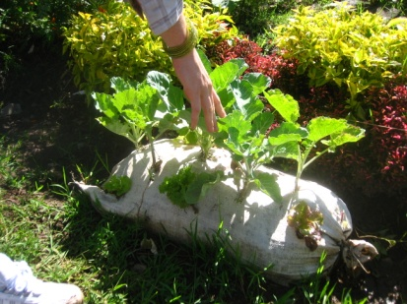
After the prison, we visited the Grow Biointensive Agriculture Centre of Kenya (G-BIACK). We learned that “biointensive agriculture” is equivalent to organic and sustainable agriculture in the US, and we toured the establishment, learning about techniques such as building an “urban garden”, or filling a sack with soil and seeds, so as to create a garden anywhere (Fig.1). We also were taught about “50 bed units”, a bed that when planted with carbon crops, root crops and income crops in the ration of 50:30:20, will feed one person for one year, as well as provide materials for compost and a small source of income. G-BIACK had also started several programs to help women and children affected by HIV/AIDS such as rabbit and goat programs, as well as crafting and sewing programs.
Figure 1: Kale growing in a sack for an "urban garden" at the G-BIACK facility.
As the sun dipped lower in the sky, we headed back across Nairobi to the Community Sustainable Development Empowerment Program (COSDEP). Even though we were more than four hours behind schedule, the COSDEP staff were very friendly and presented us with a wonderful meal, all cooked over a fire. After our late-afternoon meal, we toured the estate, learning about the chickens, cows, and the mushroom-growing operation.
The following day, we visited Flamingo Flower Farms, a vast expanse of greenhouses near Lake Niavasha that specializes in exporting roses, mainly to the UK. Though the farm claimed to be environmentally friendly, their operation was not entirely sustainable, or “biointensive” as they used various synthetic fertilizers and pesticides. However, we were told that the water used for watering the plants was collected, cleaned, and re-used.
After departing the flower farm, we headed towards Hell’s Gate National Park. Along the way, the terrain became progressively more dry and dusty and we began to see why this place was called Hell’s Gate. Since the area around the park has a particularly thin crust, a geothermal power plant was constructed to harness the energy of the heat of the earth. Unfortunately, due to timing conflicts, we were not able to tour the power plant, so we continued to Hell’s Gate, where we had planned to go on a hike. Being the outdoorsy Wyomingites that we are, we opted for the “difficult” version of the hike, which required us to be led along by a Masai guide. The hike was beautiful, leading us through canyons, up waterfalls, and along cliffs. On the bus ride back to Nairobi, we were fortunate enough to witness zebras, giraffes, water buffalo, and several other exotic animals grazing peacefully with each other alongside the road, all under the African sunset.
The subsequent day was spent on the bus, in transit to Kericho. The trek took us all day, and I spent most of the time glued to the window, absorbing as much culture as I could. As the bus slowly and carefully rolled over the washed-out and bumpy dirt roads, we were observed by the many people who stood or sat on the side of the road, selling potatoes, cabbage and carrots. The entire road from Nairobi to Kericho was like this; lined with men, women and children trying to sell their produce. When we finally arrived in Kericho, we pulled into the Tea Hotel and opted for a much belated dinner in their restaurant, though I was so travel-weary that I went immediately to bed, finding solace under the billowy mosquito net.
After awakening in the middle of tea country, we travelled down the road to the KETEPA tea packaging factory. We were informed that Kenya is one of the world’s major tea producers and that they export 95% of the tea that they grow, with only 5% winding up at local markets. In the processing plant, we were given a tour of the entire process of taking loose-leaf tea and blending, mixing, tasting, bagging, boxing, and selling it. After the tour, we were invited into the main office, where we all enjoyed a nice hot cup of Safari tea.
We then travelled to Finlay’s tea plantation, where we were shown the tea plants as well as the harvesting and drying process of the tea. The plantation was gigantic, and we were told that tea plants and eucalyptus trees were planted in a ration of 3:1, as this ratio provided exactly the right amount of eucalyptus wood to dry that amount of tea when burned. Because of this fact, we were told that the plantation was “sustainable” because it didn’t rely on outside fuel sources to dry the tea. We were also told that the plantation met the “bare minimum” requirements to be certified fair trade and to get accreditation with the Rainforest Alliance. Additionally, the plantation spokesman said that they didn’t use any pesticides, as they have never had any problems with pests on the plantation. However, we discovered that they did use synthetic fertilizers, applied aerially.
Even though Finlay’s claimed to be sustainable and environmentally friendly, most of the students in our group, including myself, had doubts. The fact that the plantation had never had a problem with pests surprised me, and I kept thinking about the fact that as far as the eye could see, there were only two kinds of plants: eucalyptus trees and tea plants. I couldn’t help but ponder the devastation that would befall the entire plantation if a single pest were to invade. Similarly, I was slightly disturbed by the fact that our tour guide really emphasized that Finlay’s had met the “bare minimum” requirements for various certifications. Finally, I began to wonder about the effect of the fertilizers on the local water supply, since we were informed that the fertilizer was applied in the amount of 100kg/hectare shortly before the rainy season. While we were touring the plantation and the processing plant, I noticed that none of the workers looked particularly happy, and I left Finlay’s feeling slightly skeptical.
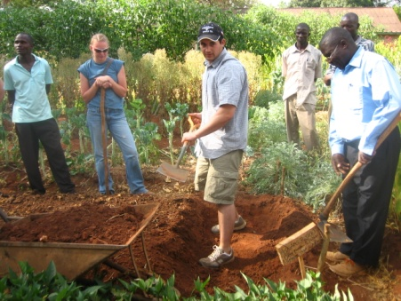
After our morning in tea country, we loaded up the bus and headed towards Kitale and the Manor House Agricultural Centre (MHAC). Upon our late arrival, we ate a traditional Kenyan dinner and then headed straight to bed in the MHAC dorms. The next morning, we awoke and received a tour of the campus, as well as tutorials on composting, draft animal power, and “double digging” (Figure 2). We learned that double digging is a technique in which vegetable beds are dug twice as deep, allowing for plants’ roots to grow down as opposed to out. This permits plants to be planted closer together, thus increasing the yield of a particular plot of land. We also learned that the most efficient way to create a compost pile is to layer dry material (i.e. corn stalks), wetter material (i.e. grass clippings), and old compost. In addition, we learned how to plant using a “diagonal offset” so that plants would be evenly and efficiently spaced. After a day of hard work on the farm, we went next door to the house of Polly, the founder of MHAC, where we were treated with soda and camel rides. Upon our return to MHAC, we ate dinner and reflected upon the day while the nearly full moon reflected down through the branches of the big acacia tree.
Figure 2: Students from the University of Wyoming learning how to double dig beds at the Manor House Agricultural Centre in Kitale, Kenya.

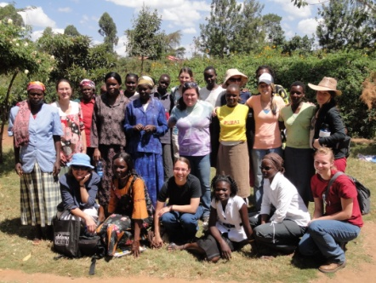
The next day, we awoke to the hot Kenyan sunshine streaming through the windows. After a traditional breakfast cooked over a cooking fire, we boarded the bus and headed out to visit three projects started by MHAC graduates. At the first of these, the Macedonia Self Help Group, we learned about composting as well as traditional medicine involving many of the plants in their gardens. After the tour, we were split up into two groups: women and men. The women in our party sat down in the shade with the women of the Macedonia Self Help Group, and we talked, “ladies with ladies” about “ladies’ issues” (Fig. 3). Three of the women spoke only Swahili, so a MHAC student had to translate for us. Among other things, we learned that it’s usually the women that do all of the work in traditional Kenya families. The women that we talked with told us that they start each day at 5:00am and then proceed to milk the animals, make breakfast, work in the fields, clean the house, make lunch, go to the market, sell produce, make dinner, milk the animals again, take care of the children, and finally go to bed at 11:00pm. They do this every single day, all year long. When we asked them what they men do, they laughed heartily before saying something along the lines of “they sit at the market and count cards”.
Figure 3: The women from the Macedonia Self Help Group with some of the women from MHAC and the women from the University of Wyoming. Photo by Liam Stockwell.
The experience of talking with the women at the Macedonia Self Help Group was incredibly powerful and left me with a profound respect for the women of Africa, the unsung heroes of everyday life. As we boarded the bus to leave, tears were shed and bonds were formed, affecting everyone. While travelling to the other projects initiated by the MHAC graduates, I remained under the spell of the incredible women that we had just met. Even as we learned about compost and natural pesticides at the Matisi Women's Group and the Kilili Self Help Group, I couldn’t take my mind off of the cultural rift between my homeland and the one that I was visiting.
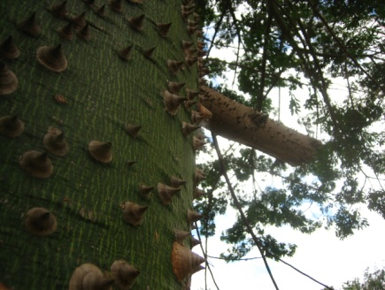
The next morning, we sorrowfully bid farewell to the Manor House, loaded up the bus, and headed into Kitale, where we toured an Agroforestry project. The project was very large with an informative and well-kept museum/visitor’s center in addition to many acres of land devoted to the cultivation of a wide variety of plants. We were given a tour, and I learned a great deal about traditional medicine (Fig. 4) as well as local lore and customs regarding certain plants. Later that afternoon, after spending several hours at the Kitale Club, we boarded a tiny plane that took us back to Nairobi, where we spent the night at Eschel Gardens.
Figure 4: This dangerous-looking tree has antibiotic properties and is traditionally used to make a tea that is used as a treatment for tonsillitis.
We spent the final three days of the trip in Narok at the Masai Mara National Park. Here, we spent most of our time in safari vans, driving across the Serengeti while observing spectacular wildlife. We witnessed such phenomena as a lioness devouring a freshly killed zebra, elephant-trampled trees, and herds of water buffalo. The experience was incredible, though it was a totally different world than all of the other places that we had seen in Kenya. We stayed at the Mara Leisure camp, which was incredibly luxurious with two swimming pools, a campfire, all-you-can-eat buffets, and indoor plumbing. Though it was a very nice resort, I had a difficult time reconciling the sheer luxury of the place with the poverty-stricken villages that we had been in just days before. We had seen villages that had no water in the middle of the dry season, yet we spent an afternoon at the Mara Leisure camp sunning ourselves and splashing in the water of the pool.
After spending several days on safari, our Kenyan adventure was coming to a close. We drove back to Nairobi, ate one final meal at Eschel Gardens, then headed to the airport where, with only minimal difficulties, we began the long journey home.
During my eleven days in Kenya, I learned volumes about sustainable agriculture as well as Kenyan culture and customs. I plan on using the knowledge that I gained about double digging, fifty bed units, diagonal offset planting, and urban gardens at ACRES, the UW student vegetable farm. I am sure that this knowledge will benefit not only ACRES, but the University of Wyoming and the Laramie community as well in the field of sustainability. I also learned that the Kenyan people are incredibly friendly, and even though we visited some very poor regions, everyone was always more than willing to prepare a feast for us, throw their best hand-embroidered cushions on the ground for us to sit on, or drop whatever they were doing to make time for us. The Kenyan people are some of the most generous, kind, and caring people that I have ever met, and I have every intention of returning to Kenya someday.
In addition to increasing my understanding of and passion for sustainable agriculture, the time that I spend in Kenya has also inspired me to continue my studies in molecular biology at the University of Wyoming, as I now have fresh motivation to pursue a career in HIV/AIDS research. Everything that I saw in Africa has changed my perception of the world, and this has effectively changed my life. I am infinitely grateful to everyone that played a hand in putting together this trip, especially Doctors Dave Wilson and Urszula Norton, Emmanuel Omondi, and Nate Storey. The knowledge that I acquired on this trip will stay with me for the rest of my life, and I am sure that it will help me with whatever I decide to do in the future.

